Mary Ann McCabe, Ph.D., ABPP
Associate Clinical Professor of Pediatrics
George Washington University School of Medicine

Resources for Coping with COVID-19 and Staying Home
General
Uplifting
https://www.facebook.com/CBSMinnesota/videos/518983372365524/
Free WiFi
**If you know of anyone, family or student, who needs free Wi Fi to stay connected, please share this link with them https://www.fox13now.com/comcast-offers-free-xfinity-wifi-nationwide-amid-covid-19-pandemic
Center for Disease Control
https://www.cdc.gov/coronavirus/2019-ncov/prepare/managing-stress-anxiety.html
World Health Organization
https://www.cmhnetwork.org/wp-content/uploads/2020/03/mental-health-considerations-WHO.pdf
Washington Post – the arithmetic of how pandemics work
https://www.washingtonpost.com/opinions/2020/03/10/coronavirus-what-matters-isnt-what-you-can-see-what-you-cant/?utm_campaign=wp_week_in_ideas&utm_medium=email&utm_source=newsletter&wpisrc=nl_ideas
Helping Parents, Families during Social Distancing
National Public Radio piece – Dr. Mary Alvord
https://thekojonnamdishow.org/shows/2020-03-24/maintaining-your-mental-health-during-coronavirus
Washington Post
https://www.washingtonpost.com/lifestyle/wellness/anxiety-coronavirus-mental-wellness-tips/2020/03/16/f187faf2-67b8-11ea-9923-57073adce27c_story.html
American Psychological Association
https://www.apa.org/practice/programs/dmhi/research-information/social-distancing
https://www.apa.org/helpcenter/pandemics
https://www.apa.org/practice/programs/dmhi/research-information/pandemics
https://www.apa.org/practice/programs/dmhi/research-information/social-distancing
Related research from APA
https://www.apa.org/news/apa/2020/03/covid-19-research-findings
https://www.apa.org/research/action/speaking-of-psychology/coronavirus-anxiety
Consortium for Science-based Information about Children, Youth and Families (CSICYF)
(This is an evidence-based web resource center developed by 7 APA divisions – 7, 15, 16, 37, 43, 53, 54.)
https://infoaboutkids.org/blog/parents-and-covid-19-helping-your-children/
Child Mind Institute
https://childmind.org/coping-during-covid-19-resources-for-parents/
https://childmind.org/article/supporting-kids-during-the-covid-19-crisis/?utm_source=newsletter&utm_medium=email&utm_content=%20Parents%20Guide%20to%20Problem%20Behavior&utm_campaign=Weekly-03-16-20
https://childmind.org/article/supporting-teenagers-and-young-adults-during-the-coronavirus-crisis/?utm_source=newsletter&utm_medium=email&utm_content=teenagers%20and%20young%20adults&utm_campaign=Weekly-03-03-20
https://childmind.org/article/how-to-avoid-passing-anxiety-on-to-your-kids/?utm_source=newsletter&utm_medium=email&utm_content=%20Parents%20Guide%20to%20Problem%20Behavior&utm_campaign=Weekly-03-16-20
Child Trends
https://www.childtrends.org/publications/resources-for-supporting-childrens-emotional-well-being-during-the-covid-19-pandemic
Dr. Rosenthal (psychologist), New York City
https://manhattanpsychologygroup.com/4-key-ways-to-cope-with-the-social-impact-of-coronavirus/
American Academy of Pediatrics
https://www.healthychildren.org/English/health-issues/conditions/chest-lungs/Pages/2019-Novel-Coronavirus.aspx
Center on the Developing Child
https://developingchild.harvard.edu/stress-resilience-and-the-role-of-science-responding-to-the-coronavirus-pandemic/
Positive Coaching Alliance, regarding youth athletes
https://positivecoach.org/ask-pca/dealing-with-disappointment-during-coronavirus-cancellations-postponements/?utm_source=pcaemail&utm_campaign=devzone&utm_content=button
National Association of School Psychologists
https://www.nasponline.org/resources-and-publications/resources-and-podcasts/school-climate-safety-and-crisis/health-crisis-resources/talking-to-children-about-covid-19-(coronavirus)-a-parent-resource
National Traumatic Stress Network
https://www.nctsn.org/resources/parent-caregiver-guide-to-helping-families-cope-with-the-coronavirus-disease-2019
https://www.nctsn.org/resources/simple-activities-children-and-adolescents
Early Learning Nation:
http://earlylearningnation.com/2020/03/a-parents-guide-to-surviving-covid-19-8-strategies-to-keep-children-healthy-and-happy/
Harvard Graduate School of Education:
https://www.gse.harvard.edu/news/uk/20/03/helping-children-cope-coronavirus-and-uncertainty
Harvard School of Public Health
https://www.health.harvard.edu/blog/how-to-talk-to-teens-about-the-new-coronavirus-2020031419192
Zero to Three
https://www.zerotothree.org/resources/3210-tips-for-families-coronavirus
Give an Hour
https://giveanhour.org/wp-content/uploads/PDF-Talking-with-your-kids.pdf
Anxiety and Depression Association of America
https://adaa.org/learn-from-us/from-the-experts/blog-posts/consumer/how-talk-your-anxious-child-or-teen-about
Authentic Connections (Dr. Luthar, psychologist)
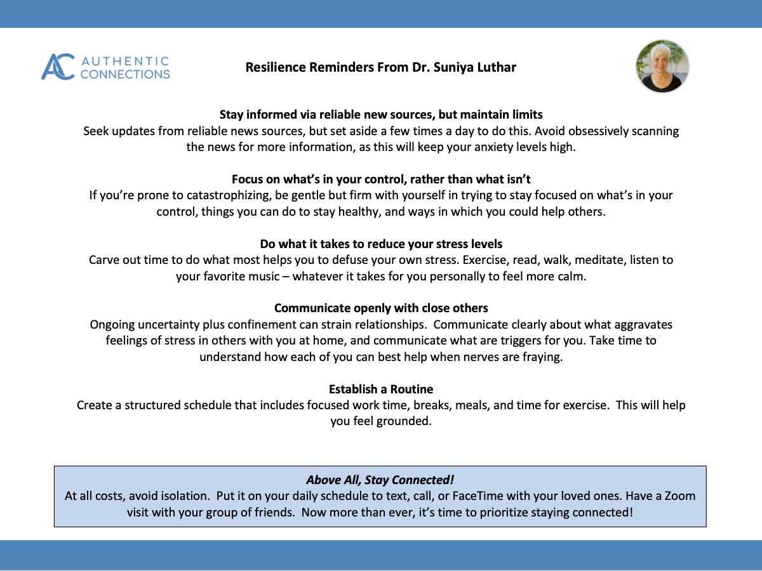
One of the most popular authors, Brene Brown, has a new podcast called Unlocking Us- check it out at her website: https://brenebrown.com/unlockingus/
Tiny Desk Concerts From NPR - the ones featured in the link are supposed to help with calm, which we could also use a little of right now: https://www.npr.org/2020/03/19/818079150/5-tiny-desk-concerts-to-calm-your-mind
Psychology Today
https://www.psychologytoday.com/us/blog/smart-parenting-smarter-kids/202003/how-talk-kids-and-teens-about-the-coronavirus
New York Times regarding parents’ questions
https://www.nytimes.com/2020/03/09/parenting/coronavirus-parents-need-to-know.html?type=roundup&link=intro&te=1&nl=nyt-parenting&emc=edit_ptg_20200314&campaign_id=118&instance_id=16740&segment_id=22213&user_id=c58475d9ebf48157b1f982ef0d7982a1&regi_id=72475170dit_ptg_20200314
Helping Teens
https://www.nytimes.com/2020/03/11/well/family/coronavirus-teenagers-anxiety.html
For Kids
Video Gaming (for teens) related to spreading outbreaks
https://www.ndemiccreations.com/en/22-plague-inc
UNICEF, for teens
https://www.unicef.org/coronavirus/how-teenagers-can-protect-their-mental-health-during-coronavirus-covid-19

ABSOLUTE EHS: Environmental, Health and Safety Consulting and Support Services

https://www.youtube.com/watch?v=dggEBYJNEQ0
National Public Radio
https://www.npr.org/sections/goatsandsoda/2020/02/28/809580453/just-for-kids-a-comic-exploring-the-new-coronavirus
https://www.npr.org/2020/03/13/815715527/the-buzz-on-bee-barf-sticky-science-behind-bumblebee-vomit
PBS
https://www.pbs.org/parents/thrive/how-to-talk-to-your-kids-about-coronavirus
Exercise
Exercise - adults:
Peloton (most of you know how much of a fan I am of their outdoor runs, strength, yoga, meditation, and of course bike and treadmill – you don’t have to have theirs)
https://www.onepeloton.com/app?utm_source=twitter&utm_medium=organic_social&sf119201153=1
Pure Barre On Demand is offering a 60 day free trial. Promo code: EXTENDEDTRIAL.
Go to https://ondemand.purebarre.com/
click the 30 day trial, start, and put in code - it extends from 30 to 60 days and puts fee to $0
Exercise – kids:
Cosmic Kids Yoga
https://www.youtube.com/user/CosmicKidsYoga
Go Noodle
https://www.gonoodle.com/

Activities for Adults and for Kids
Yale University is offering a free course online, The Science of Well-Being, that teaches you how to be happier.
Professor Laurie Santos taught a class called Psychology and the Good Life first in spring 2018 in response to concerning levels of student depression, anxiety, and stress. It became the most popular class in Yale's history and garnered national and international media attention.
To share the class' contents with a wider audience, Santos created a Coursera course. You can audit it entirely for free or opt for a $49 certificate of completion.
USA Today – 100 Things to Do
https://www.usatoday.com/story/life/health-wellness/2020/03/16/coronavirus-quarantine-100-things-do-while-trapped-inside/5054632002/
The Mighty compiled ideas about board games online:
Imaginiff is a good group game that only one person has to have, same with Scattegories or trivia, which could accommodate two or more players. Utilizing an online platform like Board Game Arena is another idea as well.
Good Gardening Videos
https://goodgardeningvideos.org/
Zoo
http://cincinnatizoo.org/home-safari-resources/
Virtual Field Trips
https://docs.google.com/document/u/0/d/1SvIdgTx9djKO6SjyvPDsoGlkgE3iExmi3qh2KRRku_w/mobilebasic?fbclid=IwAR3sWJERRaPzF5-7-GMWbW9zHDLv6ULru-9_mMnYWHTobmrfbVhi_-k0Mq4
Audio listening
https://stories.audible.com/start-listen
Libby app – the way to access e-books and audiobooks from the libraries that are now closed
https://www.overdrive.com/apps/libby/
Celebrities reading stories
https://www.storylineonline.net/
https://www.youtube.com/results?search_query=%23OperationStoryTime
Language:
https://rosettastone.com/freeforstudents/
Arts:
https://www.clevelandinnercityballet.org/single-post/2020/03/14/Cleveland-Inner-City-Ballet-to-launch-Virtual-Online-Ballet-Instruction-Program?fbclid=IwAR2DMb8IurQP6LW4yPa95-UMJArl28_L7zB40yOwPdltwsmd5Rqr2W0b23c
https://www.playbill.com/article/15-broadway-plays-and-musicals-you-can-watch-on-stage-from-home?fbclid=IwAR2bCZlcBVYUvu_ChxYzgrPEd3z3ZI3K-BhxC2s6uX0Z6AitZTKBDi3Vi-I
https://www.wkyc.com/article/entertainment/museumsofferingvirtualtours/103-3b3be900-2956-4ac3-88e3-43ec2880fc2b
Mo Willems - https://www.kennedy-center.org/education/mo-willems/

Educational Activities
https://kidsactivitiesblog.com/135609/list-of-education-companies-offering-free-subscriptions/?fbclid=IwAR1rJJfeWcU-eD8B1Ak97E8g_w9UThq54lo-6kPKQsq_ltODtc1zXhN-HKU
Science: https://www.facebook.com/TheScienceMom/posts/2555301844707352?hc_location=ufi
Math: https://www.weareteachers.com/best-math-websites/?fbclid=IwAR31ycYhzbbVpQhalduTteXUFfTa43Iqropiq-5Z82jofVpr8k-dkyYj6SY#.XnAV7rkdwWw.facebook
Educational shows
Netflix: Brainchild, The Who Was? Show, Julie’s Greenroom (about the arts), Ask the StoryBots, The Magic School Bus
Disney +: Brain Games, National Geographic
PBS: Wild Kratts, Xavier Riddle, Reading Rainbow, Between the Lions, Peg + Cat
Amazon Prime: Horrible Histories (for slightly older kids in late elementary, middle school)
Educational apps
from Originator Kids: Endless Alphabet, Endless Reader and Endless Numbers; Raz-Kids and Kiddopia.
Compiled by Michelle Simmons, HealthySteps Specialist 3/17/2020
(All ages pre-K-12)

Facebook pages:
Make – Daily art class videos to follow along with at home Born Yoga – Daily family-friendly yoga workouts
DadLab – Science experiments for young kids
McHarper Manor – Free art tutorials daily
Cincinnati Zoo and Botanical Gardens - daily live videos highlighting one of the breeds at the zoo.
Georgia Aquarium - daily live videos talking about the sea creatures and a live webcam of the tank.
YouTube: JAMaROO Kids – over 300 videos of cooking, art, music, dance and exercise classes for young children.
Websites:
Free unlimited access to videos with math and literacy activities https://fluencyandfitness.com/register/school-closures/
Watch, listen and play games to learn all about amazing animals www.switcheroozoo.com
Free access to all of NASA’s space images https://images.nasa.gov
Play games while practicing reading and math skills www.funbrain.com
Hang out with your favorite characters all while learning www.pbs.org
Go “into the book” to play games that practice reading strategies www.reading.ecb.org
Practice your phonics skills with these read-along stories www.starfall.com
Read, play games, and hang out with Dr. Seuss and his friends www.seussville.com
Practice math and reading skills all while playing fun games www.abcya.com
Read, play games, and conduct cool science experiments www.highlightskids.com https://www.brainpop.com/?fbclid=IwAR3yZTlEr_2UUTtv23ssot_QmIxLzqwz_FqXOorey3lz0xYfiG62edPTYeg
The San Diego Zoo has a website just for kids with amazing videos, activities, and games. Enjoy the tour! https://kids.sandiegozoo.org/
Tour Yellowstone National Park! https://www.nps.gov/…/lea…/photosmultimedia/virtualtours.htm
Explore the surface of Mars on the Curiosity Rover. https://accessmars.withgoogle.com/
This Canadian site FarmFood 360 offers 11 Virtual Tours of farms from minks, pigs, and cows, to apples and eggs. https://www.farmfood360.ca/
Indoor Activities for busy toddlers https://busytoddler.com/2020/03/indoor-activities/…
Play games and learn all about animals https://switchzoo.com/
Play with fave show characters and learn too https://pbskids.org/
Travel to Paris, France to see amazing works of art at The Louvre with this virtual field trip. https://www.louvre.fr/en/visites-en-ligne
This Virtual Tour of the Great Wall of China is beautiful and makes history come to life. https://www.thechinaguide.com/destinati…/great-wall-of-china
Math and Reading games https://www.funbrain.com/ Phonics skills https://www.starfall.com/h/
This iconic museum located in the heart of London allows virtual visitors to tour the Great Court and discover the ancient Rosetta Stone and Egyptian mummies. https://britishmuseum.withgoogle.com/
Read, play games, and hang out with Dr. Seuss https://www.seussville.com/
300,000+ FREE printable worksheets from toddlers to teens https://www.123homeschool4me.com/home-school-freeprintabl…/
Geography and animals https://kids.nationalgeographic.com/
Math practice from counting to algebra and geometry http://www.mathscore.com/
Fave kids books read by famous people https://www.storylineonline.net/
Crafts, activities, mazes, dot to dot, etc, https://www.allkidsnetwork.com/
High school chemistry topics https://www.acs.org/content/acs/en/education/resources/highschool/chemmatters/articlesby-topic.html?fbclid=IwAR0Tuo7MTtRk83ekCiksUxkWNvDhZ7ACdYLN_FfJ8nZswCKoPFU4SRV4MpY
Math and reading games https://www.abcya.com/
Math and language games https://www.arcademics.com/
Hands on Elem science videos https://www.backpacksciences.com/science-simplified
Voice based learning... learn through Alexa https://bamboolearning.com/resources
Fun games, recipes, crafts, activities https://www.highlightskids.com/
ClickSchooling brings you daily recommendations by email for entertaining websites that help your kids learn. https://clickschooling.com/
Math as a fun part of your daily family routine http://bedtimemath.org/ Games to get "into the book" https://reading.ecb.org/
Online history classes for all ages preteen through adults https://school.bighistoryproject.com/bhplive
Biology https://www.biologysimulations.com/ Elem Math through 6th grade https://boddlelearning.com/
Educational games K-12 https://www.breakoutedu.com/funathome Digital archive of history https://www.bunkhistory.org/
Test Prep for SAT, ACT, etc. https://www.bwseducationconsulting.com/handouts.php
Geometry https://www.canfigureit.com/
Resources for Spanish practice https://www.difusion.com/campus/
Chinese learning activities https://chalkacademy.com/
Music is for everyone https://musiclab.chromeexperiments.com/
Experiments Science, Math, Social Studies https://www.ck12.org/student/
Grammar practice for middle grades https://www.classroomcereal.com/
Daily free science or cooking experiment to do at home.http://www.clubscikidzmd.com/blog/
Chemistry https://www.playmadagames.com/
Reading passages for grades 3-12, with reading comprehension and discussion questions. https://www.commonlit.org/
Vocabulary, grammar, listening activities and games in Spanish, French, Italian, German, Portuguese, Korean, and Latin. https://conjuguemos.com/
35,000 pages of online content on the cultures and countries of the world. https://www.countryreports.org/
K-5th Science lessons https://mysteryscience.com/
Tons of free classes from leading universities and companies https://www.coursera.org/
Free printable K-8 Reading and Math activity packs (available in English and Spanish) https://www.curriculumassociates.com/supporting-students-away-fromschool?fbclid=IwAR3znJQR2EwplUI7yUIXBByr_X8iMglMBHeW1UbmHZoPNQkHX1GSZe7Kr_A
Digital learning content for preschool through high school https://www.curriki.org/
A wide range of math content from middle school through AP Calculus. https://deltamath.com/overview

